**Exercise 1: Implementing the Singleton Pattern**

**CODE:**

class Logger {

private static Logger instance;

private Logger() {

System.out.println("Object has been created");

}

public static Logger getInstance() {

if (instance == null) {

instance = new Logger();

}

return instance;

}

public void log(String mes) {

System.out.println("[Log] "+ mes);

}

}

public class Main {

public static void main(String[] args) {

Logger o1 = Logger.getInstance();

o1.log("1st instance is created");

Logger o2 = Logger.getInstance();

o2.log("2nd instance is created");

if (o1 == o2) {

System.out.println("The instances are the same");

}

}

}

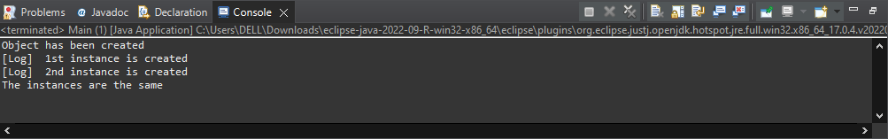

**Exercise 2: Implementing the Factory Method Pattern**

**CODE:**

interface Document {

String open();

}

class ExcelDocument implements Document{

@Override

public String open() {

return "Excel Document opened";

}

}

class PdfDocument implements Document{

@Override

public String open() {

return "Pdf Document opened";

}

}

class WordDocument implements Document{

@Override

public String open() {

return "Word Document opened";

}

}

abstract class DocumentFactory {

public abstract Document CreateDocument();

}

class ExcelFactory extends DocumentFactory{

@Override

public Document CreateDocument() {

return new ExcelDocument();

}

}

class PdfFactory extends DocumentFactory{

@Override

public Document CreateDocument() {

return new PdfDocument();

}

}

class WordFactory extends DocumentFactory{

@Override

public Document CreateDocument() {

return new WordDocument();

}

}

public class Main {

public static void main(String[] args) {

DocumentFactory worddocument = new WordFactory();

Document word = worddocument.CreateDocument();

System.out.println(word.open());

DocumentFactory pdfdocument = new PdfFactory();

Document pdf = pdfdocument.CreateDocument();

System.out.println(pdf.open());

DocumentFactory exceldocument = new ExcelFactory();

Document excel = exceldocument.CreateDocument();

System.out.println(excel.open());

}

}

